Understanding Your Spiritual SHAPE

- Have you ever struggles with feeling valuable and important? How or why?

Psalm 139:13-16
- What do those verse tell you about yourself? You are shaped by God for a purpose - You are unique - You are wonderfully complex

Before we can know our gifts, we must know this…

- The number one thing in your life that you are to be about is – Know Jesus
Matthew 22:36-39

That is our #1 goal in life – this is why we were born – is it why we breathe!

- Everyone has a gift given by God
Ephesians 4:7, Romans 12:6-8, 1 Peter 4:10, 1 Corinthians 7:7

Knowing Jesus, we are to acknowledge where our talents come from. They all come from God above - all of our positive traits, abilities, & passions.

- Are our talents the same? No
- What are some examples? Sing, speak, cooking, Art, etc.
- What are you good at? Have some share

- Your gifts are not your purpose
Our purpose in life is to bring God glory!!

- Is our purpose in life is not defined by your abilities? No - Your purpose in life never changes though our abilities may. This is important - gifts and abilities may change – our purpose will not.

- Your purpose is not your mission
This is our mission - Mark 16:15, Matthew 28:19, Acts 1:8

Your dream or “calling” in life is not your mission in life. Remember your mission is to make him known. Our mission is to build the kingdom of God.

- Is a Christians mission the same for all of us? Yes
- What are some platforms for our mission? Designer, mechanic, pastor, missionary, mom, singer

- Your mission is not your destiny
This is our destiny - Romans 8:29, Philippians 1:21, Ephesians 2:10, 4:22-24

God’s destiny for us is to become like Jesus – that is what he desires in us.

- Why do you think God’s destiny for us important to know?

Who you are becoming is more important than what you are doing!

The greatest verse (Matt 22:34) – This is our purpose – to know / love / glorify God
The great command (Matt 28:19) – This is our mission / calling – to tell the world
The great giftings (Ephesians 4:7) – This is our platform – our abilities
The great challenge (Romans 8:29) – This is our destiny – to look more like Jesus
The great process (Hebrews 6:1-3, 2 Peter 3:18) – This is our goal – maturity
- Which of these are eternal?
Regardless of changes in life – our purpose is eternal! To glorify God!

KNOWING YOUR S.H.A.P.E. - 5 things that us give insight into our mission

S – Spiritual Gifts (spiritual gifts from God to you – spiritual abilities)
Romans 12:4-8, Ephesians 4:7-13, 1 Corinthians 12:4-12

Three Categories of Spiritual Gifts

- Motivation Gifts (Giving, admin, service, speaker / teacher, encouragement, mercy, perception, etc.)

- Ministry Gifts (Pastors, teachers, prophets, apostles, evangelists)

- Manifestation / Miracle Gifts (Wisdom, Faith, knowledge, healing, miracles, discernment, tongues - Supernatural gifts)

H – Heart (your motivations, desires, and interests)
Matt. 12:34, Proverbs 4:23

A – Abilities (talents, skills, natural abilities)
Exodus 31:3

P – Personality (Our differences as people, unique traits)
Psalm 139 (read at take home)

E – Experiences (Good experiences and bad – things that shape our passions)
2 Corinthians 1:3-4, Romans 5:2-4

QUESTIONS TO ASK YOUR SELF:

- What are your passions?
  - What makes you laugh / cry / if you could do anything in life?
- What energized you as a child?

- What would you work on or do for free?
- If you were given a pay cut and still would do it.
- Letting go of your financial goals in order find your calling.

- What am I good at?
- Something I do well that I can offer or teach others
- This is confirmed by others

- Are you using your spiritual gifts and talents for the kingdom?
- How or why not?

How to discover your Gift’s
- Make Jesus Lord of your life
- Ask God, He will show you - James 1:5
- Understand your SHAPE (strength and weaknesses)
- Accept that others will confirm it
- Realize all gifts are important – you are a part of a wonderful puzzle

Take home – or do together for fun
Test can be taken on your mobile device

Spiritual gifts test - Test yourself and learn more
www.giftstest.com
www.ministrymatters.com/all/entry/4640/spiritual-gifts-discovering-and-using
https://gifts.churchgrowth.org/spiritual-gifts-survey/

Ministry Leadership test
www.fivefoldministry.com
www.5voices.com

Personality and ability tests – helpful to know your SHAPE
www.123test.com

Temperaments test
www.temperaments.fighunter.com

- Choleric (aka - Lion / Dolphin / Idealist)
- Sanguine (aka - Otter / Kangaroo / Artisans)
- Melancholy (aka - Beaver / Wombat / Guardians)
- Phlegmatic (aka - Golden retriever / Eagle / Rational)

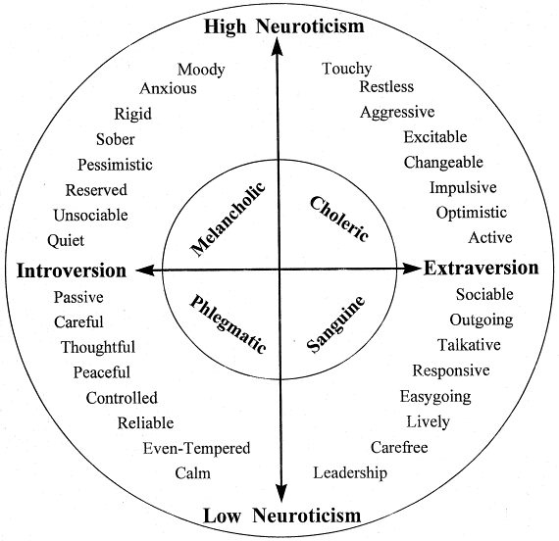

Understanding Your Spiritual SHAPE

Before we can know our gifts, we must know this…
Psalm 139:13-16

- The #1 thing in your life that you are to be about is – ___________________
Matthew 22:36-39

- Everyone has _________________________ given by God
Ephesians 4:7, Romans 12:6-8, 1 Peter 4:10, 1 Corinthians 7:7

- Your gifts are not ___________________________
Our purpose in life is to bring God glory!!

- Your purpose is not _______________________________
Mark 16:15, Matthew 28:19, Acts 1:8
Our mission is to build the kingdom of God.

- Your mission is not _______________________________
Romans 8:29, Philippians 1:21, Ephesians 2:10, 4:22-24
God’s destiny for us is to become like Jesus.

The greatest verse (Matt 22:34) – This is our purpose – to know / love / glorify God
The great command (Matt 28:19) – This is our mission / calling – to tell the world
The great giftings (Ephesians 4:7) – This is our platform – our skills / abilities
The great challenge (Romans 8:29) – This is our destiny – to look more like Jesus
The great process (Hebrews 6:1-3, 2 Peter 3:18) – This is our goal – maturity

KNOWING YOUR S.H.A.P.E. - 5 things that us give insight into our mission

S – ______________________________ (spiritual abilities)
Romans 12:4-8, Ephesians 4:7-13, 1 Corinthians 12:4-12

Three Categories of Spiritual Gifts
- Motivation Gifts (Giving, admin, service, speaker / teacher, encouragement, mercy, perception, etc.)
- Ministry Gifts (Pastors, teachers, prophets, apostles, evangelists)
- Manifestation / Miracle Gifts (Wisdom, Faith, knowledge, healing, miracles, discernment, tongues - Supernatural gifts)

H – ______________________________ (your motivations, desires, and interests)
Matt. 12:34, Proverbs 4:23

A – ______________________________ (talents, skills, natural abilities)
Exodus 31:3

P – ______________________________ (Our differences as people, unique traits)
Psalm 139 (read at take home)

E – ___________________________ (Good experiences and bad)
2 Corinthians 1:3-4, Romans 5:2-4

QUESTIONS TO ASK YOUR SELF:

- What are your passions?
- What makes you laugh / cry / if you could do anything in life?

- What would you work on or do for free?
- If you were given a pay cut and still would do it.

- What am I good at?
- Something I do well that I can offer or teach others – confirmed by others

- Are you using your spiritual gifts and talents for the kingdom?
- How or why not?

How to discover your Gift’s

- Make Jesus _____________________________
- ___________________________, He will show you - James 1:5
- Understand your SHAPE (strength and weaknesses)
- Accept that others will _________________________________
- Realize all gifts are important – you are a part of a wonderful puzzle

Take home – or do together for fun
Test yourself and learn more - Tests can be taken on your mobile device

Spiritual gifts test -
www.giftstest.com
www.ministrymatters.com/all/entry/4640/spiritual-gifts-discovering-and-using
https://gifts.churchgrowth.org/spiritual-gifts-survey/

Ministry Leadership test
www.fivefoldministry.com
www.5voices.com

Personality and ability tests – helpful to know your SHAPE
www.123test.com

Temperaments test
www.temperaments.fighunter.com

- Choleric (aka - Lion / Dolphin / Idealist)
- Sanguine (aka - Otter / Kangaroo / Artisans)
- Melancholy (aka - Beaver / Wombat / Guardians)
- Phlegmatic (aka - Golden retriever / Eagle / Rational)

